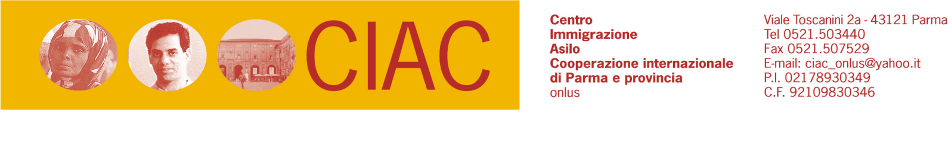

Scheda per consulenza
COGNOME NOME
CITTADINANZA DOMICILIO RESIDENZA
+
PERMESSO DI SOGGIORNO SI-CARTA DI SOGGIORNO GENERE TELEFONO/CELL.
PROBLEMA ESPOSTO:
__________________________________________________________________________________________________________________________________________________________________________________________________________________________________________________________________________________________________________________________________________________________________________________________________________________________________________________________________________________________________________________________________________________________________________________________________________________________________________________________________________________________________________________________________________________________________________________________________________________________________________________________________________________________________________________________________________________________________________________________________________________________________________________________________________________________________________________________________________________________________________________________________________________________________________________________________
VIENE RICHIESTA CONSULENZA LEGALE. APPUNTAMENTO PER IL …………………………………………………………....
Luogo____________________ Data____________________
Firma ____________________________________________
IL/la sottoscritto/a è informato ai sensi dell’art. 10 L. 275/96 posto a tutela e protezione del trattamento dei dati personali, che gli stessi dati verranno utilizzati al fine di consentire l’espletamento dell’incarico conferito, potranno essere comunicati a terzi soggetti interessati per l’espletamento della richiesta consulenza, presta il consenso alla loro utilizzazione, in particolare ai sensi dell’art. 22 L 275/96, in base all’autorizzazione n. 4/2000 per la protezione dei dati personali presto consenso e autorizzo la raccolta e il trattamento dei dati sensibili, unicamente per le finalità inerenti l’incarico ricevuto.
Luogo____________________ data / /
Firma leggibile___________________________

POSSIBILE SOLUZIONE TECNICO GIURIDICA
_______________________________________________________________________________________
______________________________________________________________________________________
______________________________________________________________________________________
______________________________________________________________________________________
______________________________________________________________________________________
______________________________________________________________________________________
______________________________________________________________________________________
______________________________________________________________________________________
______________________________________________________________________________________
______________________________________________________________________________________
______________________________________________________________________________________
______________________________________________________________________________________
______________________________________________________________________________________
______________________________________________________________________________________
______________________________________________________________________________________
______________________________________________________________________________________
______________________________________________________________________________________
______________________________________________________________________________________
______________________________________________________________________________________
______________________________________________________________________________________
______________________________________________________________________________________
______________________________________________________________________________________
______________________________________________________________________________________
______________________________________________________________________________________
______________________________________________________________________________________
______________________________________________________________________________________

